**Day - 8**

**(Class- Movie)**

Question:-

1. **https://github.com/rvsp/typescript-oops/blob/master/Practice/Movie.md**

The class Movie is stated below. An instance of class Movie represents a film. This

class has the following three properties:

● title, which is a String representing the title of the movie

● studio, which is a String representing the studio that made the movie

● rating, which is a String representing the rating of the movie (i.e. PG13, R,

etc)

a) Write a constructor for the class Movie, which takes a String representing the title

of the movie, a String representing the studio, and a String representing the rating as

its arguments, and sets the respective class properties to these values.

b) The constructor for the class Movie will set the class property rating to “PG” as

default when no rating is provided.

c) Write a method getPG, which takes an array of base type Movie as its argument,

and returns a new array of only those movies in the input array with a rating of “PG”;.

You may assume the input array is full of Movie instances. The returned array need

not be full.

d) Write a piece of code that creates an instance of the class Movie with the title

“"mersal”, the studio "thendral studio", and the rating “PG13”

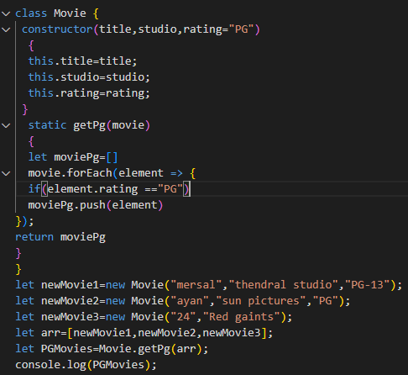

Answer:-

**0**: Movie {title: 'ayan', studio: 'sun pictures', rating: 'PG'}

**1**: Movie {title: '24', studio: 'Red giants’, rating: 'PG'}

**Circle - Class**

2. Question:

**https://github.com/rvsp/typescript-oops/blob/master/Practice/class-circle.md**

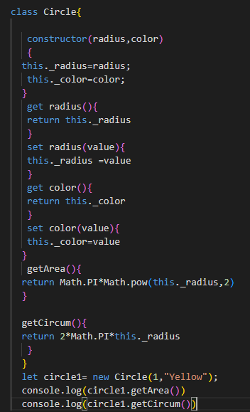

Answer:-

3.141592653589793

6.283185307179586

3. Write a “person” class to hold all the details.

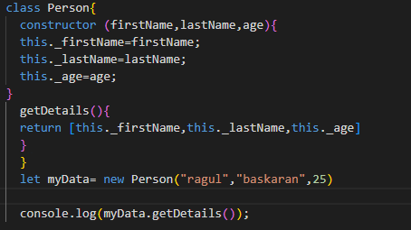

**Output:**

['ragul', 'baskaran', 25]

4. write a class to calculate the uber price.

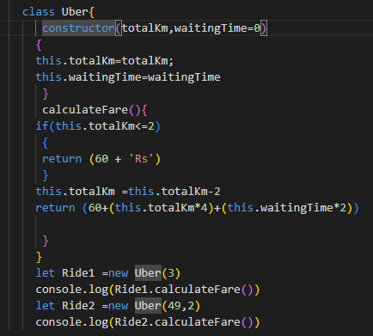

**Output:**

64

252